

HITWITTY WORLD

Online Shopping

Senior Project

By

**Wael Daibes**

Submitted to the School of Arts & Science of the

Lebanese International University

In part of fulfillment of the requirements for the degree of  **BACHERLOR OF SCIENCE IN**

**COMPUTER SCIENCE AND INFORMATION TECHNOLOGY**

**Supervised by: Dr. ALI CHOUMANE**

Spring 2023-2024



|  |
| --- |
| Human resources management system  (cosmetics ecommerce store) |
|  |
| May 24  LIU Nabatiyeh 2024  Authored by: Wael Daibes 42130928 |

# Index

# Presentation:

# 1- Objective................................................................................................................................4

# 2 – System management objective .........................................................................................5

# 3 –software needs......................................................................................................................5

# 4 – hardware requirements .......................................................................................................5

# Story board:

# 1- home page...............................................................................................................................6

# 2 – Search bottom ......................................................................................................................7

# 3 – categories page ....................................................................................................................8

# 4 – product page..........................................................................................................................9

# 5 – cart page ................................................................................................................................10

# 6 – about us...................................................................................................................................11

# 7 – contact us ...............................................................................................................................12

# 8 - login ..........................................................................................................................................13

# 9 – manager dashboard ................................................................................................................14

# 10 – admin page..............................................................................................................................15

# 11 – category page..........................................................................................................................16

# 12 – task page..................................................................................................................................17

# 13 – add task page ..........................................................................................................................17

# 14 – contact info page .....................................................................................................................18

# Business Process:

# 1- business process table................................................................................................................19-20

# Use case:

# 1- all usecase................................................................................................................................21

# 2 – use case user .........................................................................................................................22-23

# 3 – use case employee .................................................................................................................24

# 4 – use case common (employee + manager) .............................................................................25

# 5 – use case manager ....................................................................................................................26-27-28

# Use Case Narrative:

# 1- checkout......................................................................................................................................29-30-31

# 2 – add payment method ...............................................................................................................31-32

# 3 – add to Wishlist ..........................................................................................................................32-33

# 4 – login to the system....................................................................................................................33-34

# 5 – dashboard overview and analysis……....................................................................................34-35-36

# 6 – admin managment....................................................................................................................36-37-38

# 7 –employee managment...............................................................................................................38-39-40

# 8 – category management ................................................................................................................40-41

# 9 – daily task management ...............................................................................................................41-42

# ER Diagram:

# 1- ER diagram....................................................................................................................................43

# conclusion:

# 1- GitHub link.....................................................................................................................................44

# Objective:

To streamline operations and enhance efficiency within our cosmetics ecommerce store through the implementation of a robust system management solution, empowering employees with the tools and resources necessary to optimize processes and deliver exceptional customer experiences.

Empowering business owners or team leaders with a system to track the works of their teams and manage any problems occurs in the day work in the most efficiency way to solve the problem and avoid more problems that may not seen without this system and the most important to save time for the team leader or the business owner that use this system.

# System Management Objectives:

# platform that centralizes product management, inventory control, and order processing, simplifying workflows for employees and enhancing operational transparency. Implement an integrated ecommerce

# Integrate automated reporting functionalities to generate real-time insights on sales performance, customer behavior, and inventory levels, enabling informed decision-making and strategic planning.

# Provide comprehensive training and ongoing support to employees to maximize proficiency and utilization of the ecommerce system, fostering a culture of continuous learning and improvement.

# Continuously evaluate and optimize system performance based on feedback from employees and key performance indicators, striving for continuous enhancement and innovation.

# Foster a culture of accountability and empowerment among employees by providing them with the necessary tools and resources to excel in their roles within the ecommerce store.

# Software Needs:

# Visual studio

# XAMPP

# Hardware requirements:

# It is a web application.

# STORY BOARD

# 

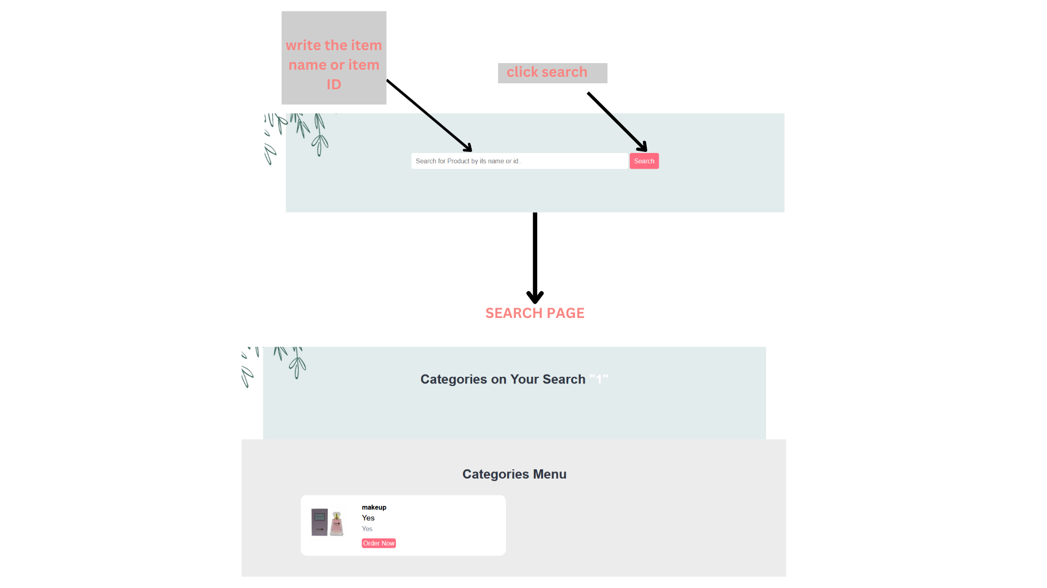

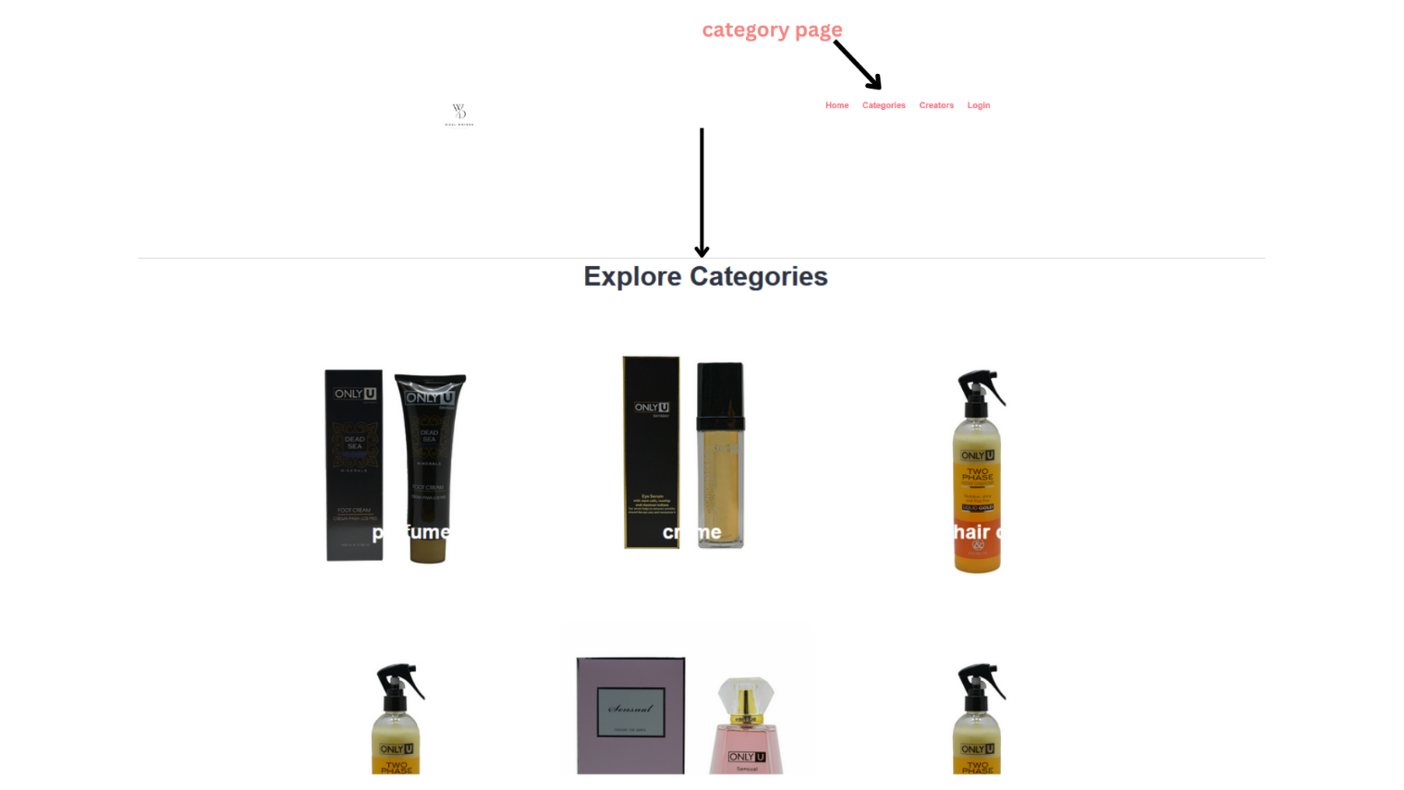

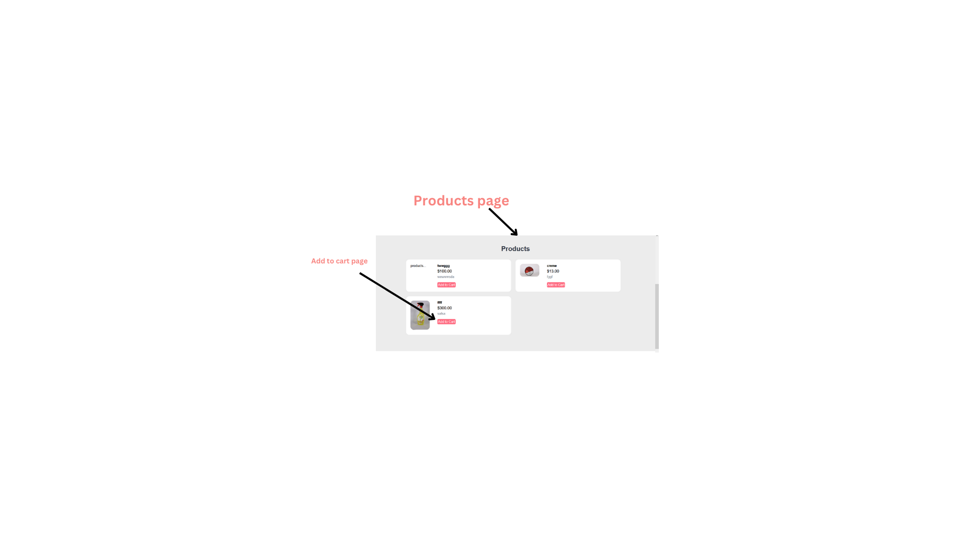

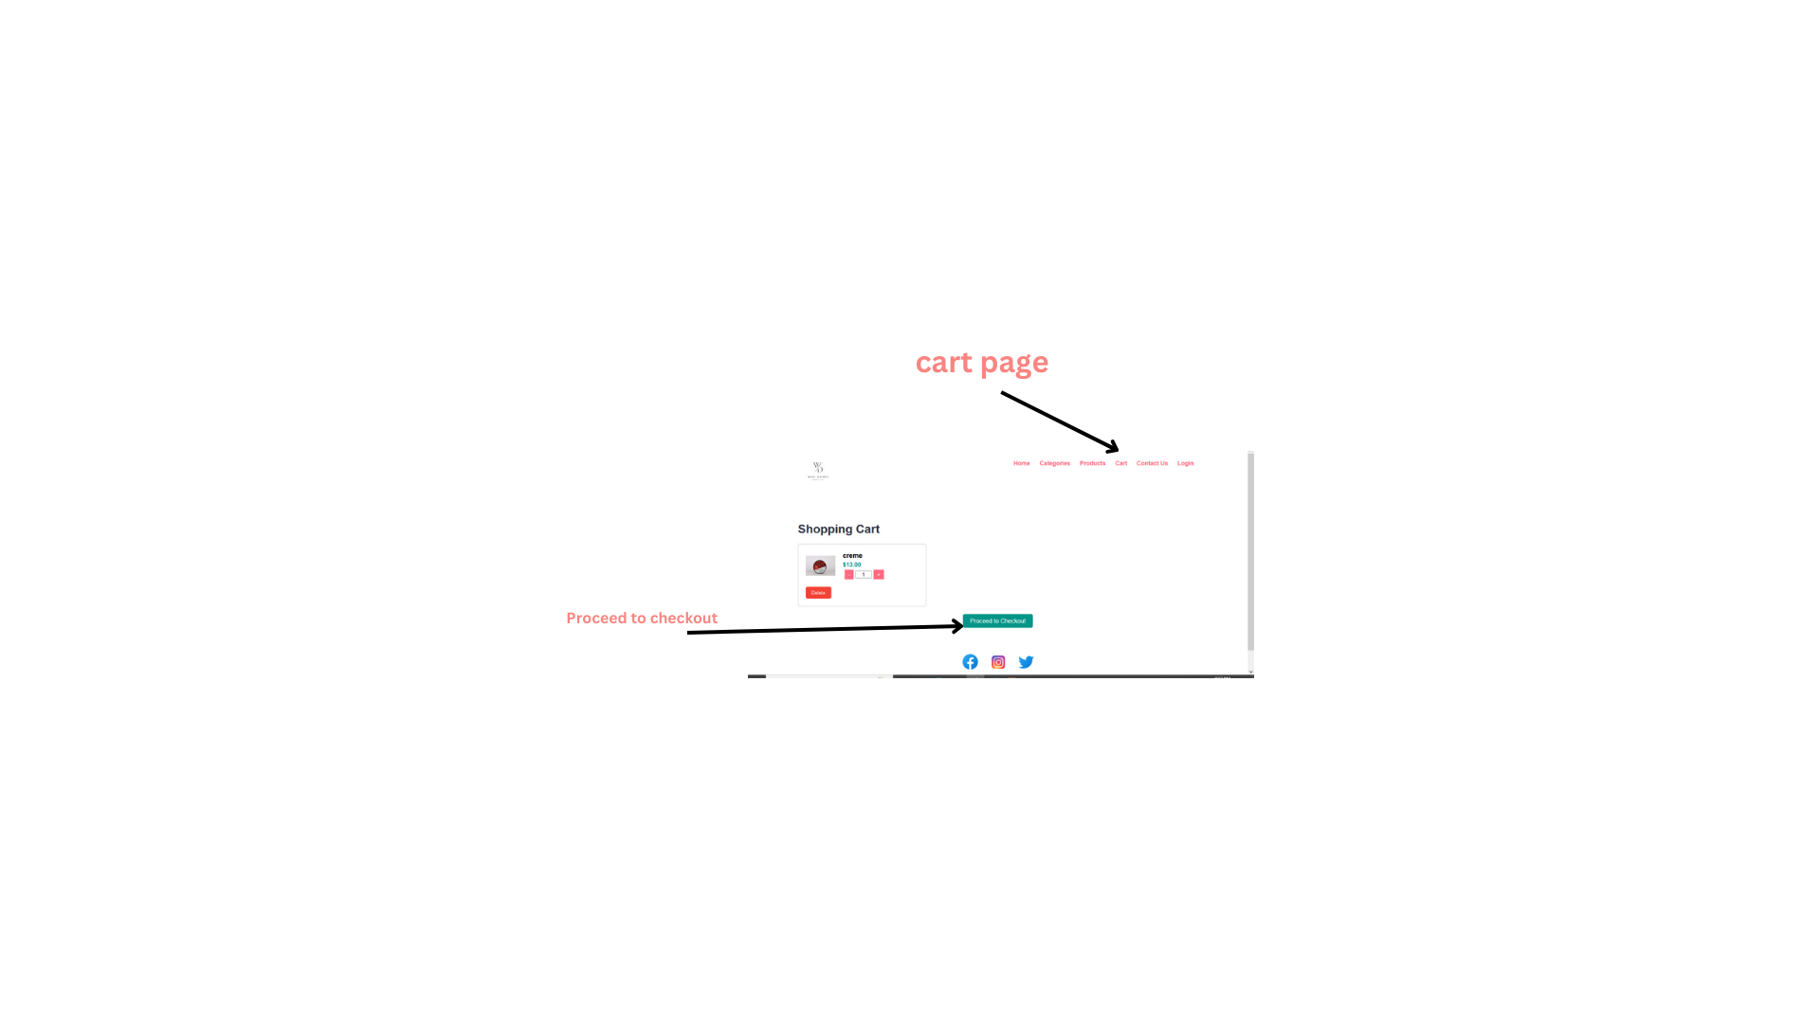



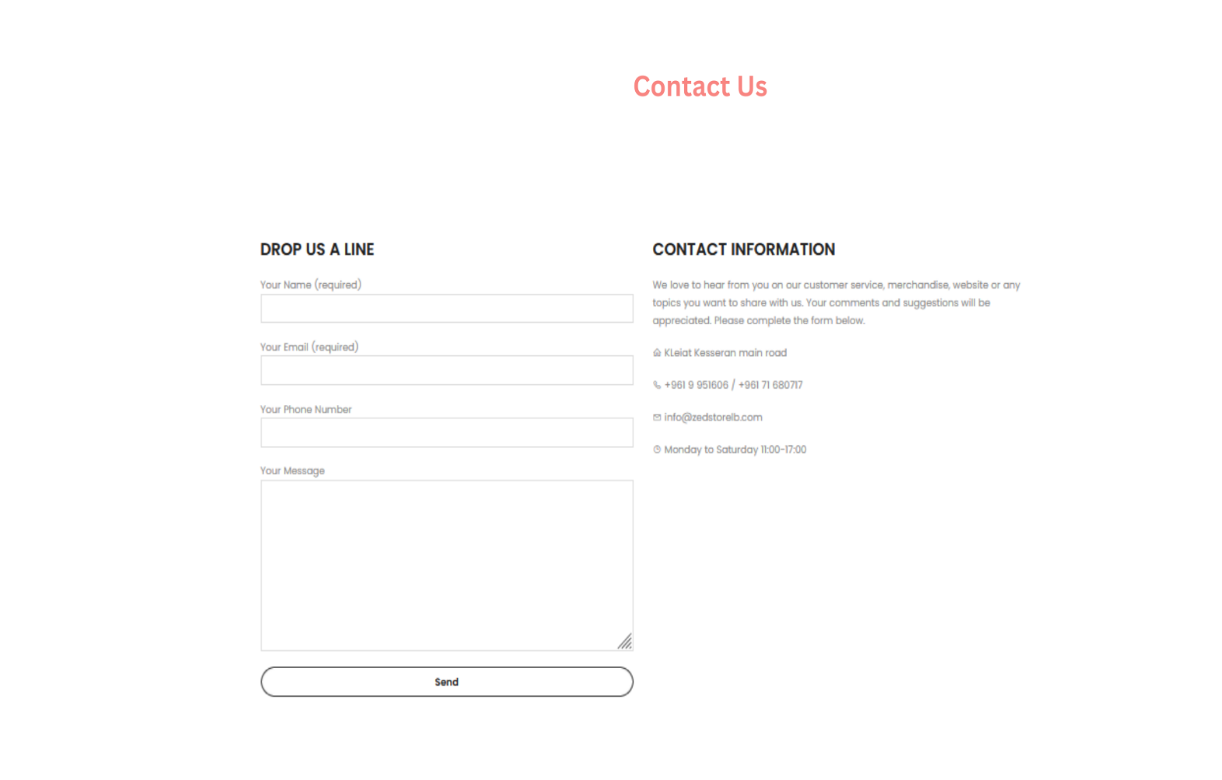

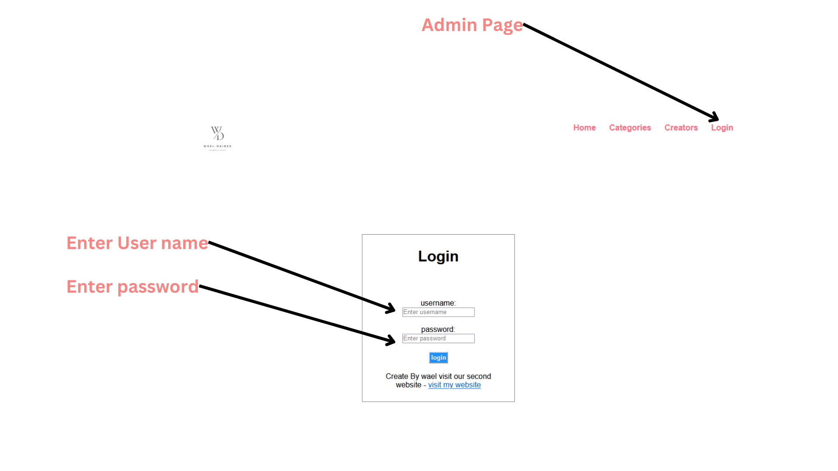

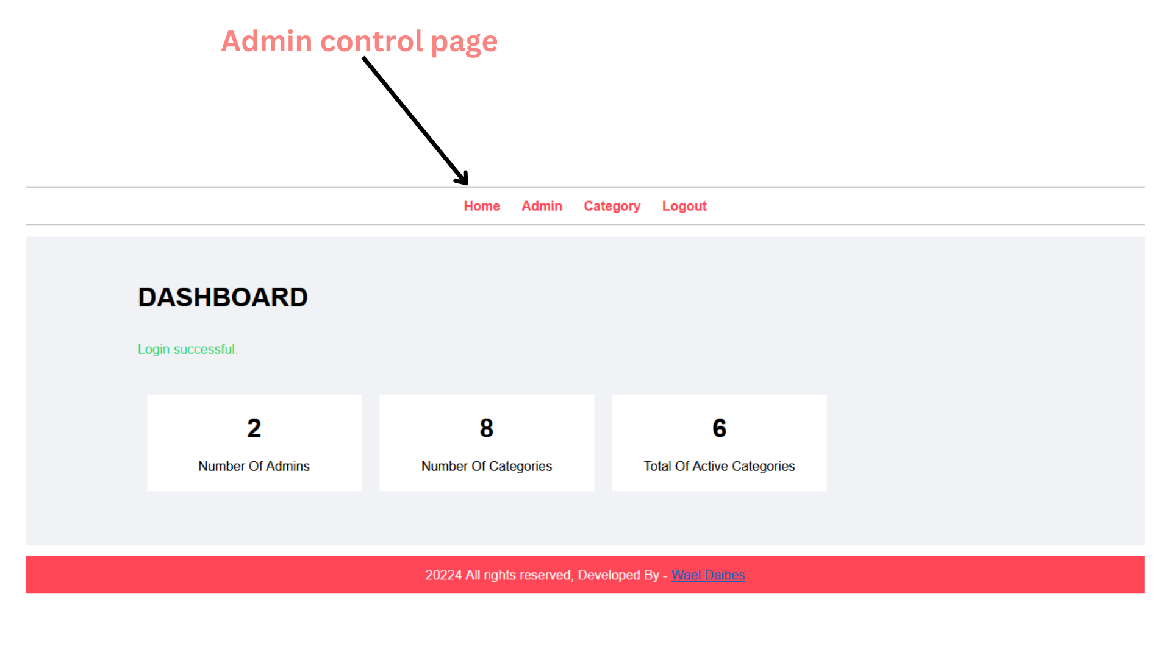

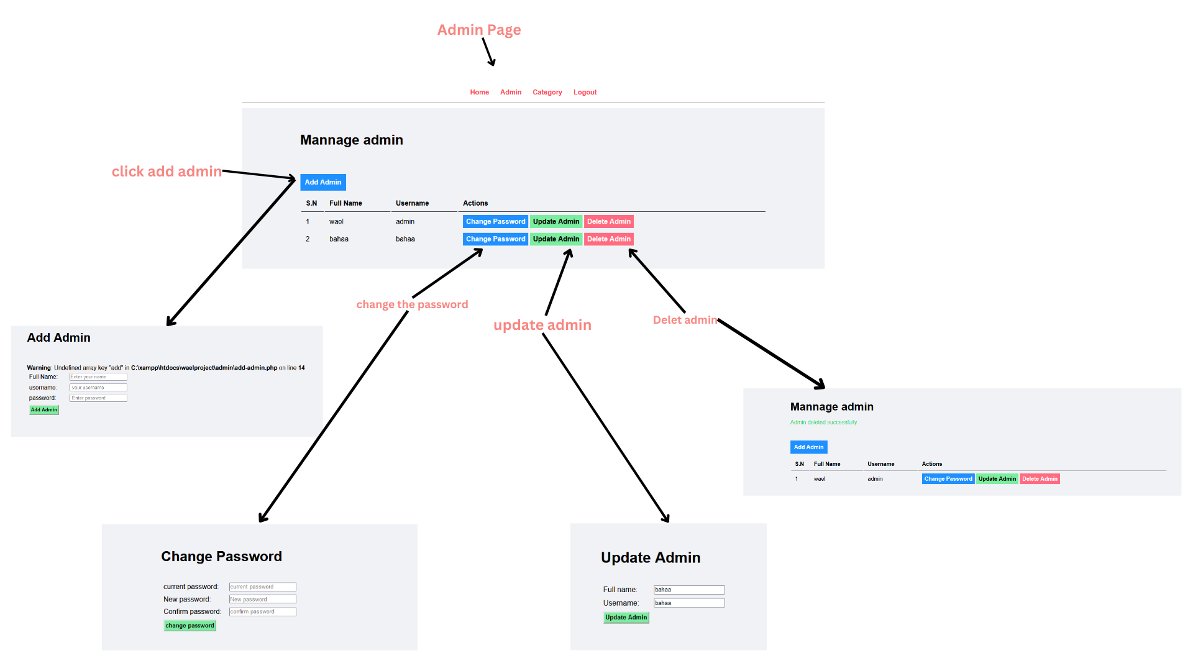

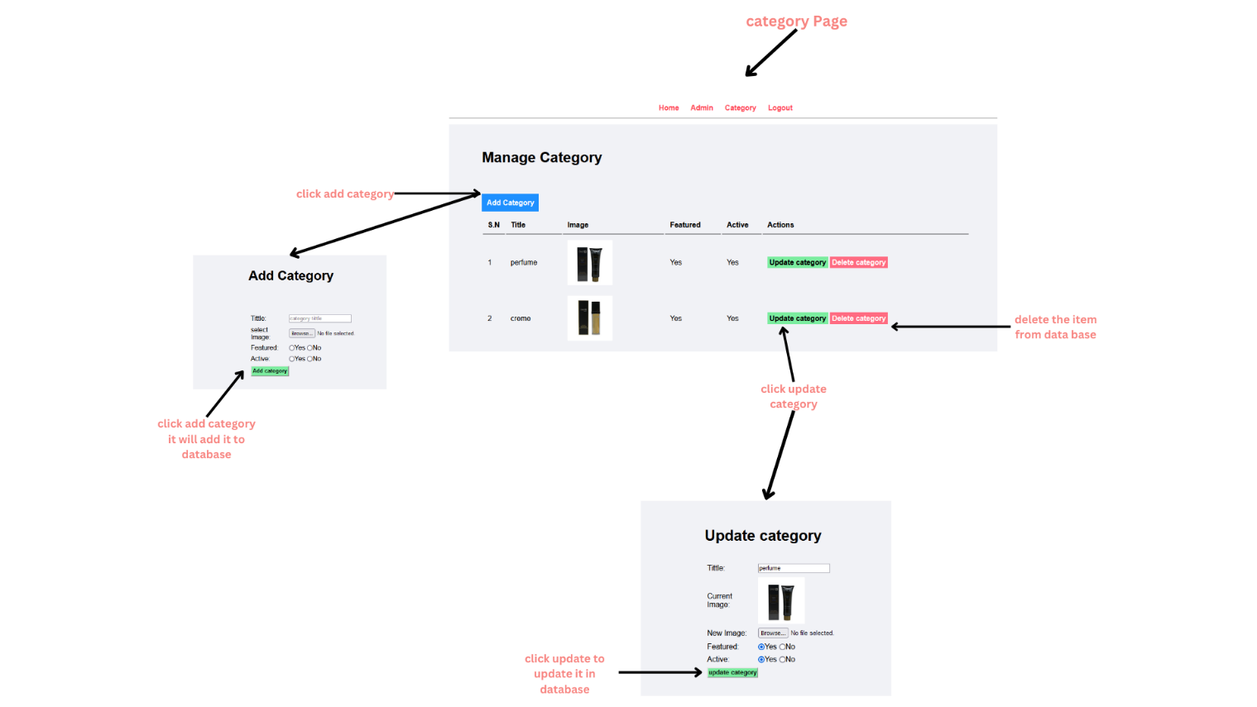

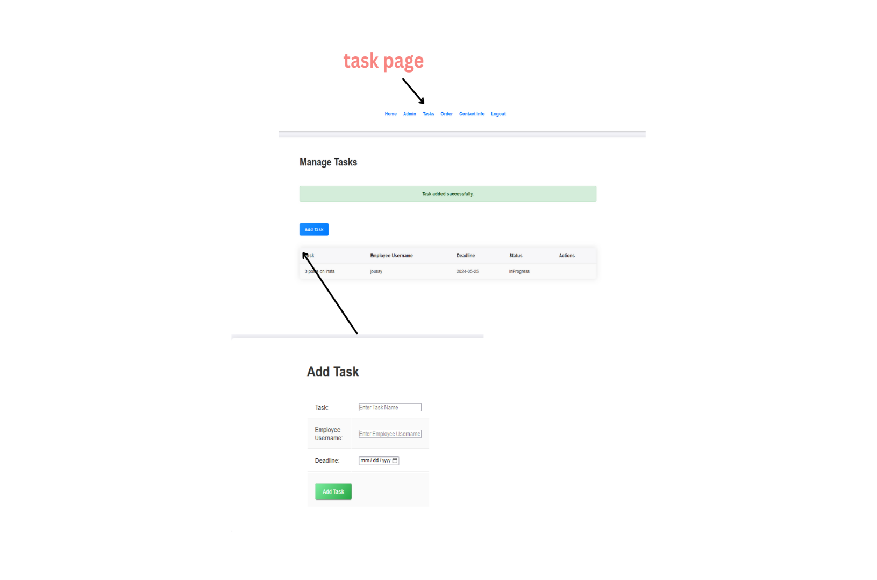

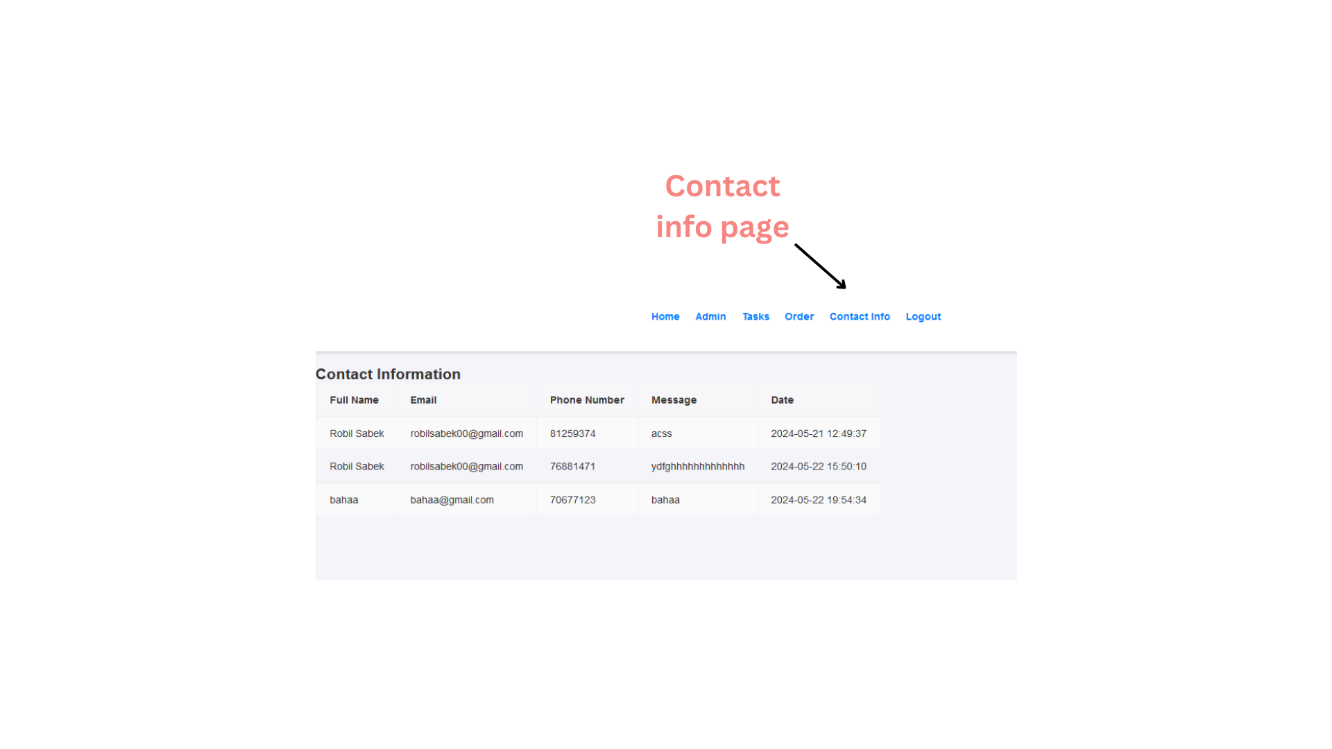

BUSSINESS PROCESS

|  |  |  |  |  |  |
| --- | --- | --- | --- | --- | --- |
|  | idea | | | | |
| tasks | cost/hour | start date | end date | duration(hour) | total cost |
| meeting 1 | $ 15 | 2/1/2024 | 2/3/2024 | 2 | $ 30 |
| research after meeting | $ 15 | 2/3/2024 | 2/5/2024 | 5 | $ 75 |
| meeting 2 (planing) | $ 15 | 2/5/2024 | 2/6/2024 | 2 | $ 30 |
|  | research | | | | |
| market research | $ 25 | 2/6/2024 | 2/8/2024 | 7 | $ 175 |
| competitors research | $ 25 | 2/8/2024 | 2/10/2024 | 7 | $ 175 |
|  | requirments(hardware-software) | | | | |
| choose e-commerce platform | $ - | 2/10/2024 | 2/11/2024 | 1 | $ - |
| cutomize the platform | $ - | 2/10/2024 | 2/11/2024 | 2 | $ - |
|  | Website Development And Design | | | | |
| front-end | $ 15 | 2/11/2024 | 2/20/2024 | 30 | $ 450 |
| database | $ 20 | 2/20/2024 | 2/24/2024 | 5 | $ 100 |
| back-end | $ 30 | 2/24/2024 | 3/10/2024 | 50 | $ 1,500 |
|  | Product Listing and Content Creation | | | | |
| Gather product information | $ 15 | 3/10/2024 | 3/13/2024 | 10 | $ 150 |
| create high quality images | $ 15 | 3/13/2024 | 3/18/2024 | 10 | $ 150 |
| optimize content for SEO | $ 20 | 3/18/2024 | 3/24/2024 | 5 | $ 100 |
|  | payment gateway | | | | |
| integrate payment gateway | $ 20 | 3/24/2024 | 3/31/2024 | 10 | $ 200 |
|  | analtics and reporting | | | | |
| implement analtics tools | $ 20 | 4/1/2024 | 4/2/2024 | 3 | $ 60 |
|  | security | | | | |
| implement security tools | $ 30 | 4/2/2024 | 4/2/2024 | 10 | $ 300 |
| monitor the system conectivity | $ - | 4/2/2024 | 5/2/2024 | 0 | $ - |
|  |  |  |  |  |  |
|  |  |  | days = | 91 |  |
|  |  |  | hours= | 159 |  |
|  |  |  | cost= | $ 3,500 |  |

USE CASE

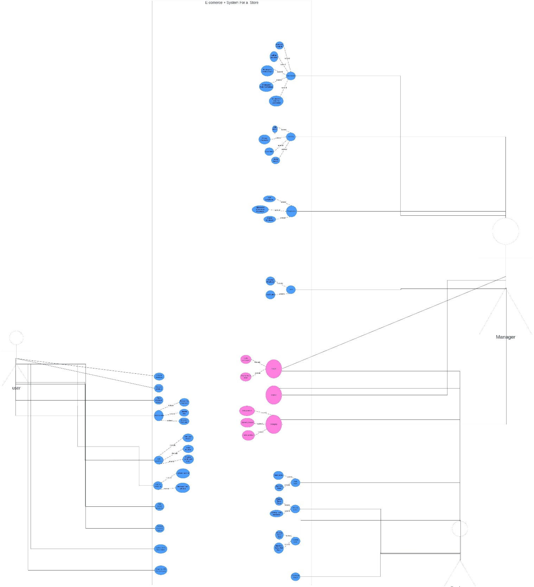

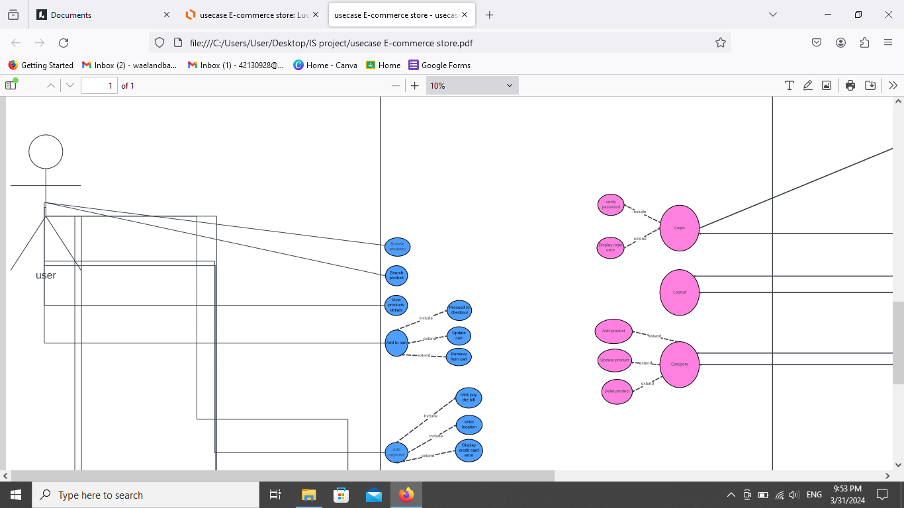

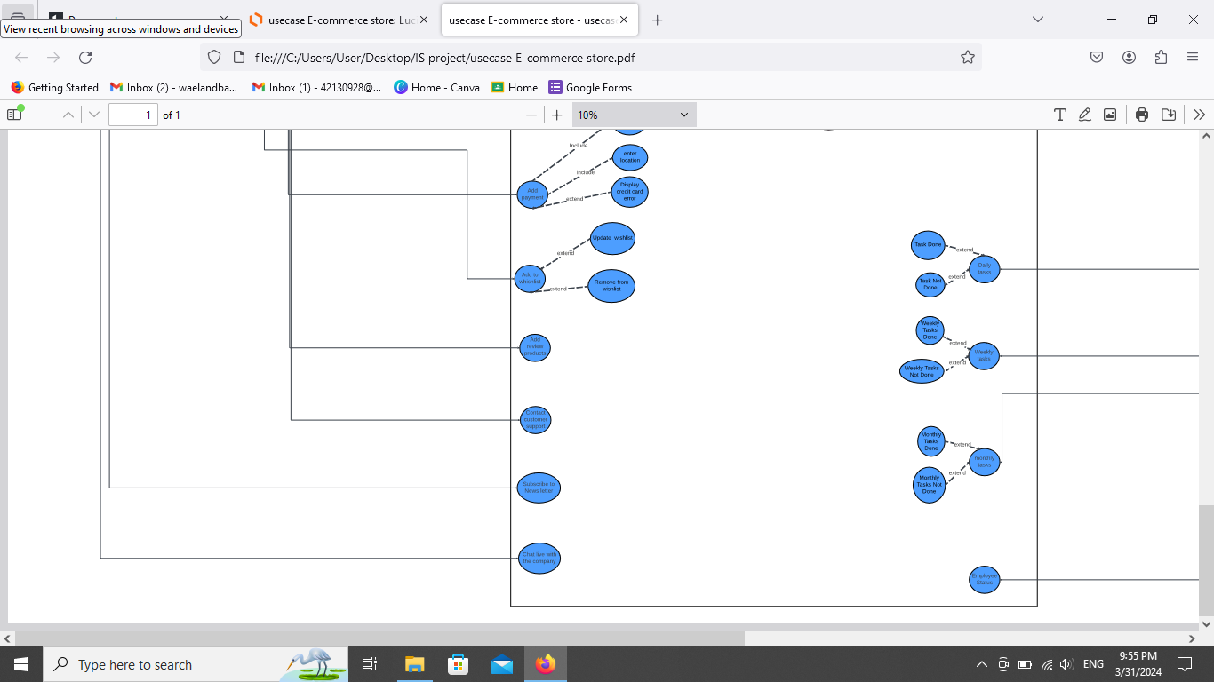

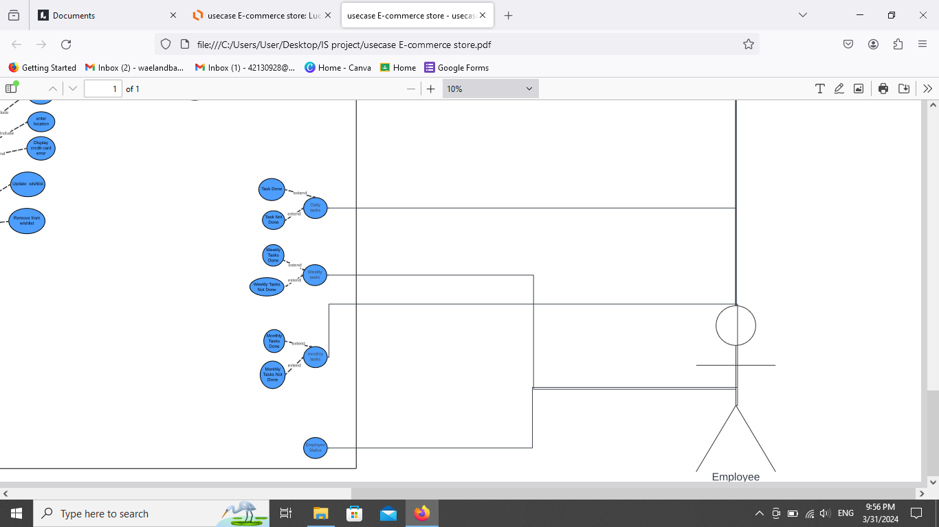

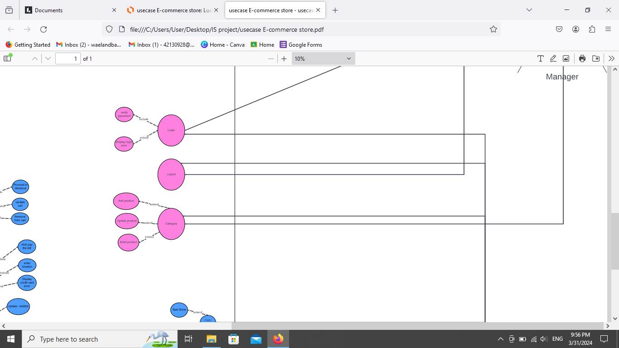

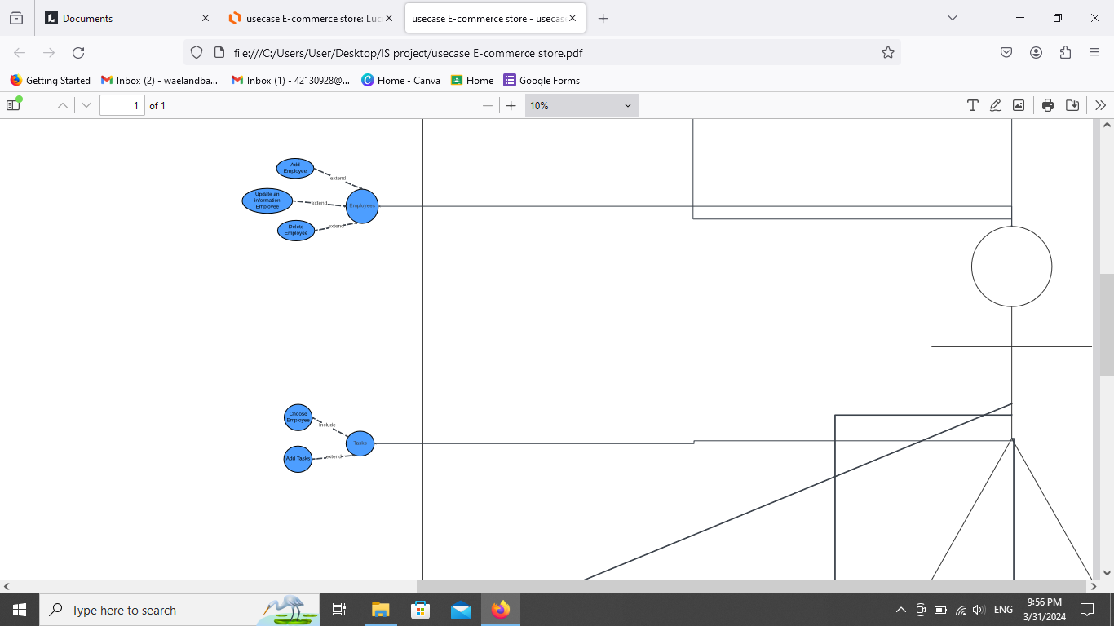

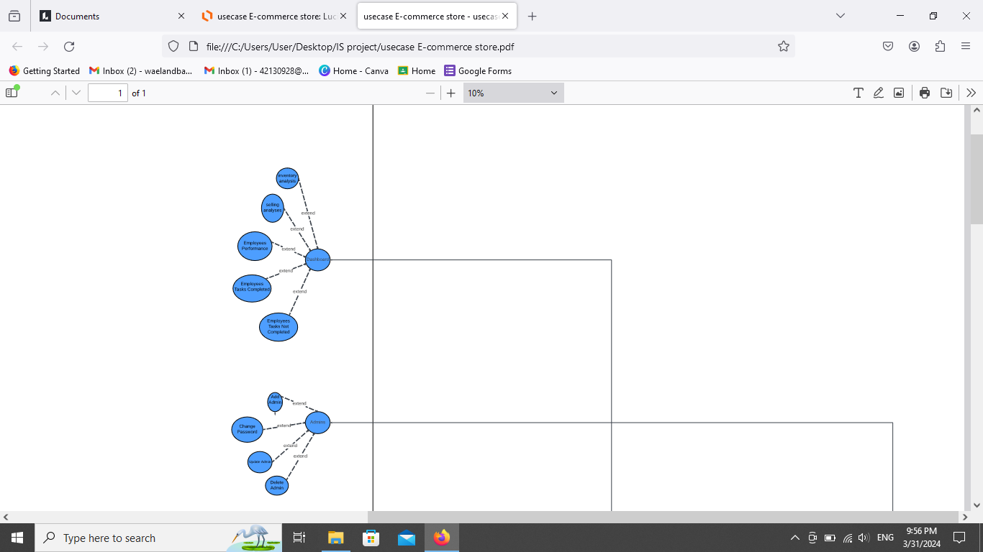

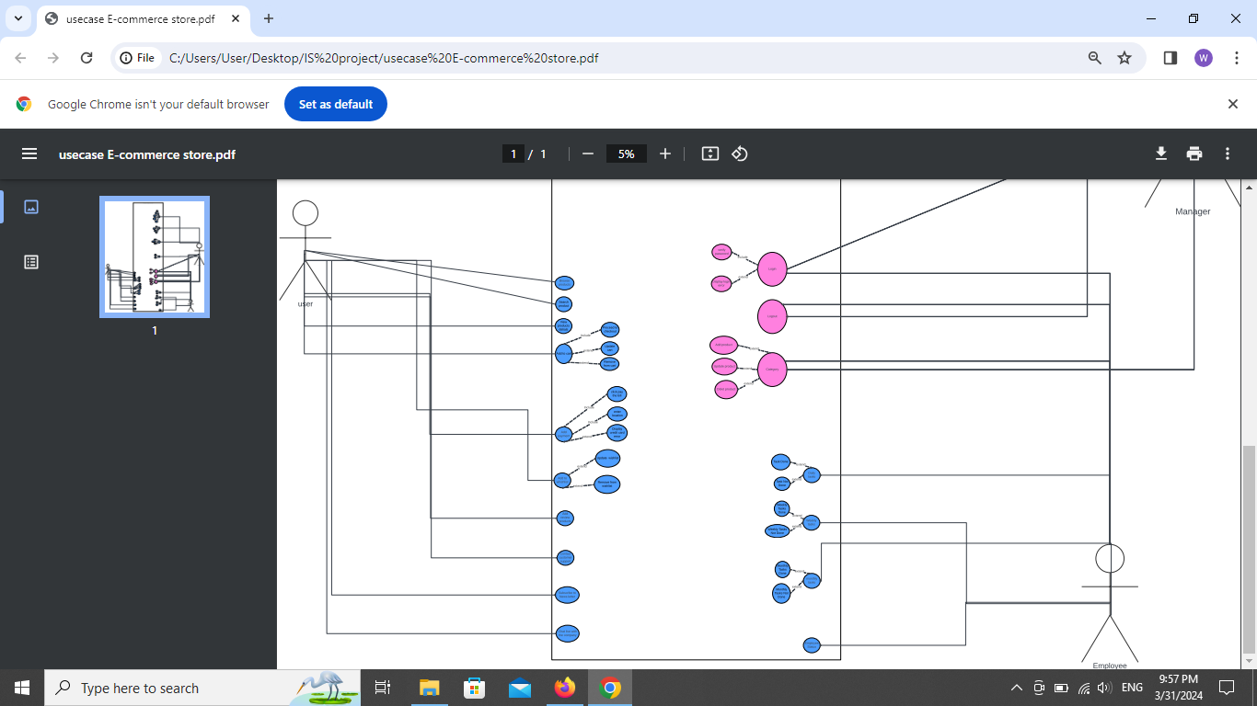

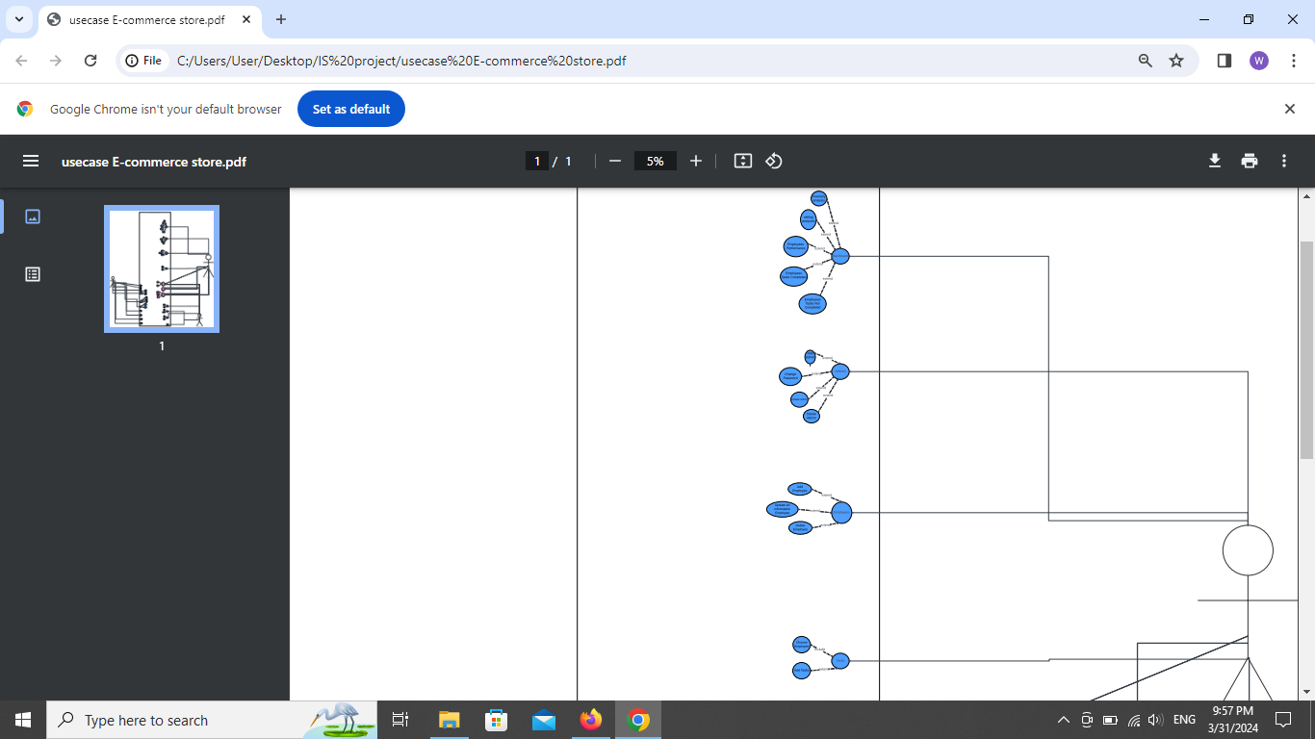

USE CASE NARRITIVE

|  |
| --- |
| 1-Use case name: Checkout |
| Actor(s):customer-online retail |
| Brief Description:  This use case allow user (customer) navigates to their shopping cart and selects the option to proceed to checkout. |
| **Basic Flow:**  1-Authentication: The system verifies the customer's login credentials and confirms their identity.  2-**Shipping Address Entry**:  *The customer enters the shipping address for the delivery of the purchased items.  *If the address is already saved, they can select it from their saved addresses.  *The system validates the address format and ensures it is correct.  3-**Shipping Method Selection**:  *The customer chooses a shipping method from the available options (e.g., standard shipping, express shipping).  *The system calculates the shipping charges based on the selected method and the delivery address.  3-**Payment Information Entry**:  *The customer provides payment information, which may include credit card details, PayPal account, or any other accepted payment method.  *The system encrypts and securely processes the payment information to ensure confidentiality and integrity.  *The customer may also have the option to use any saved payment methods associated with their account.  4-**Order Review**:  *The system displays a summary of the order, including the items, quantities, shipping address, shipping method, and total cost.  *The customer reviews the order details to ensure accuracy and makes any necessary adjustments.  *They may also apply any discount codes or promotional offers at this stage.  5-**Order Confirmation**:  *The customer confirms their order by clicking on the "Place Order" button.  *The system generates an order confirmation message, which includes an order number and estimated delivery date.  *The customer receives a confirmation email with the same information. |
| Alternative Flow:  1-**Payment Failure**:  *If the payment transaction fails (e.g., insufficient funds, declined card), the system prompts the customer to provide an alternative payment method.  *The customer can update their payment information and retry the payment.  *If multiple attempts fail, the system may suggest contacting customer support for assistance.  2-**System Error**:  If there is a technical issue or system error during the checkout process, the system displays an error message and prompts the customer to try again later or contact customer support for assistance. |
| Pre-conditions:  *The customer has selected one or more items for purchase.  *The customer is logged into their account on the online retail store platform. |
| Post-conditions:  *Order is successfully placed, and customer receives confirmation.  *Items are prepared for shipping and dispatched to the provided address.  *Payment is processed, and the appropriate amount is deducted from the customer's chosen payment method. |

|  |
| --- |
| 2-Use case name: Add Payment Method |
| Actor(s): customer-online retail |
| Brief Description:  User navigates to the "Payment Methods" section in their account settings. |
| Basic Flow:  1-**Selection of Add Payment Method Option**:  *User selects the option to add a new payment method.  2-**Payment Method Entry**:  *User provides details of the new payment method, such as credit card information, PayPal account, or any other accepted payment method.  *User may also choose to add a billing address associated with the payment method.  3-**Validation**:  *System validates the entered payment method details to ensure correctness and completeness.  *If any errors are found, the system prompts the user to correct them.  4-**Confirmation**:  *Once the payment method details are validated, the user confirms the addition of the new payment method.  5-**Notification**:  *System notifies the user that the new payment method has been successfully added to their account. |
| Alternative Flow:  1-**Invalid Payment Method Details**:  *If the entered payment method details are invalid or incomplete, the system prompts the user to correct the errors before proceeding.  *User re-enters the payment method details, and the process continues from step 3 of the basic flow.  2-**System Error**:  If there is a technical issue or system error during the process, the system displays an error message and prompts the user to try again later or contact customer support for assistance. |
| Pre-conditions:  *User is logged into their account on the cosmetics e-commerce store platform.  *User wants to add a new payment method. |
| Post-conditions:  User's account now includes the newly added payment method, which can be used for future transactions. |

|  |
| --- |
| 3-Use case name:Add to wishlist |
| Actor(s): User |
| Brief Description:  *User navigates to the product page of the item they want to add to their wish list. |
| Basic Flow:  1-**Selection of Add to Wish List Option**:  *User locates the "Add to Wish List" button or icon on the product page.  *User clicks on the "Add to Wish List" button.  2-**Confirmation**:  *System adds the selected item to the user's wish list.  *System displays a confirmation message confirming that the item has been successfully added to the wish list.  3-**Optional: Viewing Wish List**:  *User may choose to view their wish list immediately after adding the item.  *User navigates to their account settings or profile where the wish list is located. |
| Alternative Flow:  1-**Item Already in Wish List**:  *If the user attempts to add an item to the wish list that is already present, the system displays a message indicating that the item is already in the wish list.  2-**System Error**:  If there is a technical issue or system error during the process, the system displays an error message and prompts the user to try again later or contact customer support for assistance. |
| Pre-conditions:  *User is logged into their account on the online retail store platform.  *User is browsing a product they are interested in adding to their wish list. |
| Post-conditions:  The selected item is added to the user's wish list for future reference. |

|  |
| --- |
| 4-Use case name:login to the system |
| Actor(s):Manager-Employee |
| Brief Description:  User navigates to the login page of the system of the e-commerce store. |
| Basic Flow:  1-**Input Credentials**:  *User enters their registered email address or username in the provided field.  *User inputs their password in the designated field.  2-**Authentication**:  *System validates the entered credentials against the stored manager or employee data.  *If the entered credentials match, the system proceeds to authenticate the user.  3-**Successful Authentication**:  *System confirms the user's identity and grants access to the manager or employee account.  *Manager or employee is redirected to their system account dashboard. |
| Alternative Flow:  1-**Invalid Credentials**:  *If the entered credentials do not match any registered user data, the system displays an error message indicating invalid login credentials.  *User is prompted to re-enter their credentials or reset their password.  2-**Account Lockout**:  *After a certain number of failed login attempts, the system may temporarily lock the user's account for security purposes.  *User is notified about the account lockout and instructed on how to regain access, such as through a password reset process or contacting customer support.  3-**Forgot Password**:  *If the user forgets their password, they can select the "Forgot Password" option.  *The system provides a password reset link or sends a temporary password to the user's registered email address for account recovery. |
| Pre-conditions:  *manager or employee has access to the login system of the e-commerce store.  *manager or employee has registered an account on the e-commerce store platform. |
| Post-conditions:  *manager or employee is successfully logged into their account on the e-commerce store system.  *manager has access to their account features, such as browsing products, managing orders, add employee, and updating account settings. |

|  |
| --- |
| 5-Use case name: Dashboard Overview and Analysis |
| Actor(s): manager |
| Brief Description:  Administrator navigates to the dashboard section after logging into the system. |
| Basic Flow:  1-**Inventory Analysis**:  *System retrieves real-time data regarding inventory status, including available stock, low stock alerts, and popular items.  *Administrator views graphical representations and tabular data showing inventory trends, such as top-selling products, slow-moving items, and inventory turnover rate.  *Administrator can filter and drill down into specific categories or product types for detailed analysis.  2-**Selling Analysis**:  *System compiles data on sales performance, revenue, and profitability over a specified period.  *Administrator examines graphs and charts displaying sales trends, revenue breakdown by product or category, and comparison with previous periods.  *Administrator can identify best-selling products, analyze sales channels' effectiveness, and spot opportunities for growth.  3-**Employees Performance**:  *System aggregates performance metrics for employees, such as sales targets achieved, customer satisfaction ratings, and productivity.  *Administrator reviews individual employee performance dashboards, which may include key performance indicators (KPIs) like sales volume, average order value, and customer retention rate.  *Administrator identifies high-performing employees for recognition and incentive programs.  4-**Employees Task Analysis**:  *System provides an overview of tasks assigned to employees, categorizing them as completed or pending.  *Administrator assesses the status of tasks, including deadlines, priority levels, and dependencies.  *administrator identifies bottlenecks or areas requiring additional support and allocates resources accordingly. |
| Alternative Flow:  1-**Real-time Data Update**:  *If there's a delay in retrieving real-time data, the system displays a notification indicating that the information displayed may not be current.  *Administrator can manually refresh the dashboard or wait for the system to update automatically.  2-**Data Retrieval Error**:  *If there's a technical issue or connectivity problem preventing the system from retrieving data, the system displays an error message.  *Administrator is prompted to check network connection or contact technical support for assistance. |
| Pre-conditions:  *Administrator is logged into the system.  *Employees are registered and have assigned tasks. |
| Post-conditions:  *Administrator gains insights into inventory management, sales performance, and employee productivity through the dashboard analysis.  *Administrator can make data-driven decisions to optimize operations, enhance customer satisfaction, and improve overall business performance. |

|  |
| --- |
| 6-Use case name: Admin Management |
| Actor(s): Super Administrator |
| Brief Description:  Super Administrator navigates to the Admin Management section in the system. |
| Basic Flow:  1- **Add Admin**:  * Super Administrator selects the option to add a new Administrator.  * Super Administrator enters the required details for the new Administrator, such as username, email address, and initial password.  * System verifies the uniqueness of the username and email address.  * Super Administrator assigns appropriate permissions and roles to the new Administrator.  * System confirms the successful addition of the new Administrator.  2- **Change Password**:  * Super Administrator selects the option to change the password of an existing Administrator.  * Super Administrator selects the Administrator whose password needs to be changed.  * Super Administrator enters a new password for the selected Administrator.  * System validates the new password according to predefined security requirements.  * System updates the password for the selected Administrator and confirms the change.  3- **Update Admin**:  * Super Administrator selects the option to update the details or permissions of an existing Administrator.  * Super Administrator selects the Administrator whose details need to be updated.  * Super Administrator modifies the necessary details, such as username, email address, or assigned roles.  * System validates the changes and updates the Administrator's information accordingly.  * System confirms the successful update of the Administrator's details.  4- **Delete Admin**:  * Super Administrator selects the option to delete an existing Administrator.  * Super Administrator selects the Administrator to be deleted.  * System prompts for confirmation before proceeding with the deletion.  * Super Administrator confirms the deletion action.  * System removes the selected Administrator from the system and confirms the successful deletion. |
| Alternative Flow:  1- **Invalid Input**:  * If any entered data during the add, change password, or update admin processes is invalid or does not meet the system requirements, the system prompts the Super Administrator to correct the errors before proceeding.  2- **Permission Error**:  * If a regular Administrator attempts to access the Admin Management section, the system denies access and displays a permission error message.  * The regular Administrator is instructed to contact the Super Administrator for assistance.  3- **System Error**:  * If there is a technical issue or system error during any of the admin management processes, the system displays an error message and prompts the Super Administrator to try again later or contact technical support for assistance. |
| Pre-conditions:  * Super Administrator is logged into the system.  * There is at least one existing Administrator account. |
| Post-conditions:  *The desired actions (addition, password change, update, deletion) related to Admin management are successfully performed. |

|  |
| --- |
| 7-Use case name: Employee Management |
| Actor(s):system adminstartor |
| Brief Description:  * System Administrator navigates to the Employee Management section in the system. |
| Basic Flow:  1- **Add Employee**:  * System Administrator selects the option to add a new employee.  * Required details for the new employee, such as name, email address, position, and department, are entered into the system.  * System verifies the uniqueness of the employee's email address to prevent duplication.  * System Administrator assigns necessary roles, permissions, and access levels to the new employee.  * System confirms the successful addition of the new employee.  2- **Update Employee**:  * System Administrator selects the option to update an existing employee's details.  * System Administrator selects the employee whose details need to be updated.  * The required details, such as name, email address, position, department, or assigned roles, are modified as needed.  * System validates the changes and updates the employee's information accordingly.  * System confirms the successful update of the employee's details.  3- **Delete Employee**:  * System Administrator selects the option to delete an existing employee from the system.  * System Administrator selects the employee to be deleted.  * System prompts for confirmation before proceeding with the deletion.  * System Administrator confirms the deletion action.  * System removes the selected employee's record from the system and confirms the successful deletion. |
| Alternative Flow:  1- **Invalid Input**:  * If any entered data during the add or update employee processes is invalid or does not meet the system requirements, the system prompts the HR Manager or System Administrator to correct the errors before proceeding  2- **Permission Error**:  * If a regular user attempts to access the Employee Management section, the system denies access and displays a permission error message.  * The user is instructed to contact the HR Manager or System Administrator for assistance.  3- **System Error**:  * If there is a technical issue or system error during any of the employee management processes, the system displays an error message and prompts the HR Manager or System Administrator to try again later or contact technical support for assistance. |
| Pre-conditions:  * System Administrator is logged into the system.  * There is at least one existing employee record in the system. |
| Post-conditions:  *The desired actions (addition, update, deletion) related to employee management are successfully performed. |

|  |
| --- |
| 8-Use case name: Category Management |
| Actor(s): Administrator |
| Brief Description:  * Administrator navigates to the Category Management section in the system. |
| Basic Flow:  1- **Add Category**:  * Administrator selects the option to add a new category.  * Administrator enters the required details for the new category, such as name, description, and any other relevant information.  * System verifies the uniqueness of the category name to prevent duplication.  * Administrator confirms the addition of the new category.  * System adds the new category to the system and confirms successful addition.  2- **Update Category**:  * Administrator selects the option to update an existing category.  * Administrator selects the category to be updated.  * Administrator modifies the necessary details of the category, such as name, description, or any other attributes.  * System validates the changes and updates the category information accordingly.  * System confirms the successful update of the category.  3- **Delete Category**:  * Administrator selects the option to delete an existing category.  * Administrator selects the category to be deleted.  * System prompts for confirmation before proceeding with the deletion.  * Administrator confirms the deletion action.  * System removes the selected category from the system and confirms successful deletion. |
| Alternative Flow:  1- **Invalid Input**:  * If any entered data during the add or update category processes is invalid or does not meet the system requirements, the system prompts the administrator to correct the errors before proceeding.  2- **Permission Error**:  * If a regular user attempts to access the Category Management section, the system denies access and displays a permission error message.  * The user is instructed to contact the administrator for assistance.  3- **System Error**:  * If there is a technical issue or system error during any of the category management processes, the system displays an error message and prompts the administrator to try again later or contact technical support for assistance. |
| Pre-conditions:  * Administrator is logged into the system.  * There are existing categories and products in the system. |
| Post-conditions:  * The desired actions (addition, update, deletion) related to category management are successfully performed. |

|  |
| --- |
| 9-Use case name: Daily Task Management |
| Actor(s):Employee |
| Brief Description:  * Employee navigates to the daily task Management section in the system. |
| Basic Flow:  1- **Task Done**:  * Employee accesses the daily task list assigned to them.  * Employee selects a task from the list.  * Employee completes the task within the specified time frame.  * Employee marks the task as "done" or "completed" in the system.  * System updates the task status to indicate it has been completed.  * Supervisor can view the updated task status in real-time.  2- **Task Not Done**:( If an employee is unable to complete a task)  * Employee accesses the daily task list.  * Employee selects the task that was not completed.  * Employee provides a reason for not completing the task (e.g., insufficient time, unexpected issue).  * Employee notifies the Supervisor about the incomplete task and the reason behind it.  * Supervisor reviews the reason provided by the employee.  * Supervisor may reschedule the task for the employee or assign it to another employee based on priority and workload.  * System updates the task status to indicate it was not completed and records the reason provided by the employee. |
| Alternative Flow:  1- **Task Reassignment**:  * If a task cannot be completed by an employee, the Supervisor may reassign it to another employee.  * The reassigned employee receives a notification about the newly assigned task.  2- **Task Priority Change**:  * If a higher-priority task emerges during the day, the Supervisor may adjust the task list accordingly, reprioritizing tasks as necessary.  * Employees are notified of any changes to their task assignments and priorities. |
| Pre-conditions:  * Employee and Supervisor are logged into the system.  * Daily tasks are assigned and scheduled for each employee. |
| Post-conditions:  * The daily tasks are managed efficiently, with completed tasks marked accordingly and incomplete tasks addressed by the Supervisor. |

ER Diagram

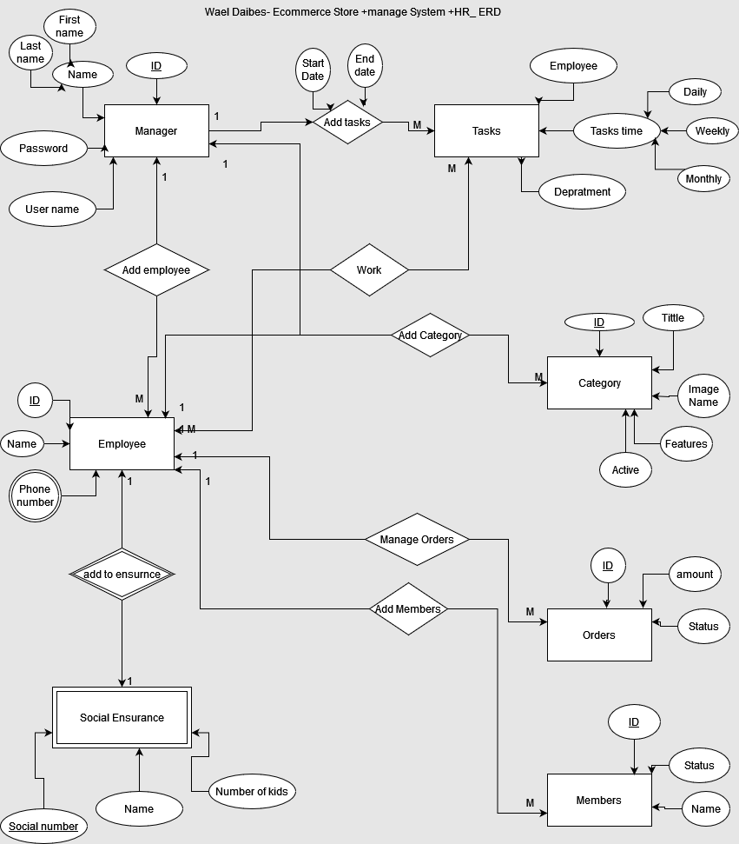

CONCLUSION

GITHUB LINK:

https://github.com/waeldaibes/cosmetic-store.git